The Eight Laws of Strength Training
1. You must train consistently
- lifter who trains twice per week for 52 weeks out of the year will see better long-term results than the lifter who trains five times per week for 20 weeks out of the year.
- Consistency is the name of the game, and the lifter who trains week in and week out will experience good gains in strength and muscularity over time.
2. You must work hard and smart.
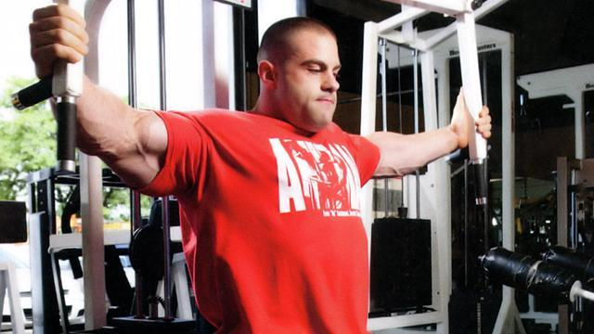
- You must also experiment to figure out what works best for you. Despite demonstrating foolish behavior in many other aspects of their lives, some "meathead" bodybuilders and powerlifters are actually incredibly intelligent when it comes to their training. Training hard is good. Training smart is good. Combine the two and you've got the best of both worlds.
3. You must consistently stimulate the musculature of the entire body.
- If a muscle never gets activated, it won't grow. To make a muscle grow, it must be stimulated on a regular basis.Even the core and quad muscles get activated sufficiently during heavy deadlifting. This helps explain why the deadlift is such a great exercise.
- Make sure that you incorporate exercises into your programs that combine to hit the entire body's musculature.
4. Progressive overload
- You must use heavier loads and perform more reps over time.

5. You must warm-up.
You can't just walk into the weight room and bench, squat, or deadlift a 1RM. Doing so will cause injury. Some folks need 30 minutes of warming up to feel right, while others only need 5 minutes. But everyone must get the blood flowing before lifting heavy loads.
Some lifts don't require much warming up, such as the hip thrust and row variations. Once you're warm and have completed the sets in your first exercise, then you don't need to warm-up for subsequent movements for the same muscle groups.
But failing to take the warm-up seriously will eventually result in disaster. Beginners typically ignore the warm-up and learn the hard way to take this component of the training session more seriously.
6. You must use good form most of the time.
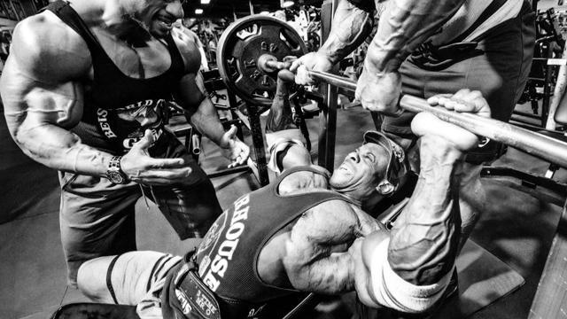
Walk into any weight room and you'll typically see people at one end of the technique spectrum or the other. Some lifters are very strict, perhaps even too strict, as they never use appreciable loads due to their robotic technique; others should reduce the weight dramatically and stop relying on momentum and energy leaks.
You certainly have some wiggle room in terms of form, as its been shown that slight momentum can increase torque requirements and muscle activation (Arandjelovic 2012). Your form will also break down a bit if you test your max at strategic points in the year.
However, most of the time you need to be very strict with your exercise form, and you need to learn the right type of form for your body on the various lifts. This is especially important for squats and deadlifts. Failure to do so will result in pain and injury, which will stop progress in its tracks.

7. You must consume adequate nutrition.
The best training program in the world is no match for a crappy diet. If you want to build a good physique and perform optimally, then you must take nutrition seriously.
You need to take in the right amount of calories and the right blend of macronutrients for your goals and physiology. You don't have to be perfect, but eating a bunch of crap day in and day out won't allow you to reach your potential, and will prevent you from building momentum in terms of strength and hypertrophy gains.
8. You must sleep well and avoid persistent distress.
Similar to nutrition, if you aren't sleeping well or are stressed out around the clock, your physiology will be working against you. Some folks need more sleep than others, but you should care about your sleep and prioritize it.
Make genuine effort to be consistent with your sleep if you're serious about getting results. Failure to do so will hinder your pursuit of strength and hypertrophy.
Regarding stress, your goal should not be to eliminate it altogether, but rather to optimize it. It's good to be challenged in life, but there's a fine line between eustress (positive or curative stress; like a good workout) and distress (negative stress; like in movies that Liam Neeson's characters tend to experience).
Stay in eustress most of the time for maximum results. Step back and analyze your life choices and habits. This is an area in which many lifters can make adjustments that lead to immediate results.
Conclusion
There aren't many absolutes in the strength training or bodybuilding field, as genetics and goals tend to dictate the efficacy of many of the industry's widely accepted best practices.
However, these 8 Laws of Strength Training are as solid as an 800-pound deadlift – and if you're not doing them, then you're probably spinning your wheels as they determine 80-90% of your results.
Get these 8 laws down to a science, and then add whatever "almost laws" from my past article that best suit your goals.

